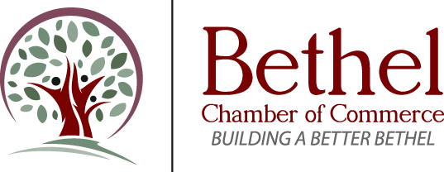 [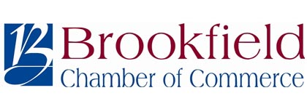](http://brookfieldchamber.org/)

[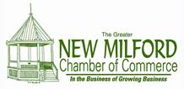](http://www.newmilford-chamber.com/)

**\*\*\*NETWORKING OPPORTUNITY\*\*\***

The New Milford Chamber held its first Business Featured event in June of 2014 followed by a multi-Chamber Business Featured event in May 2015. They have been such successful networking opportunities for our members and local businesses that we’re going to do it again.   
  
Please join us for a multi-Chamber ***Business Featured*** networking event:

**Wednesday, August 5th**

**5:30 to 7:30 pm**

[](https://www.sbdanbury.com/)

**314 Danbury Road New Milford, CT 06776**

Come join us as we have the opportunity to tour their new branch and network with one another.  
  
• This event is free and open to the public.   
• Come prepared with a 30 second to 1 minute elevator pitch so folks can learn about you and your business.  
• Please RSVP by August 1st, [**NMCC@newmilford-chamber.com**](mailto:NMCC@newmilford-chamber.com) or 860-354-6080.

“Why is networking important?”

Networking can help local businesses build leads and uncover new opportunities as well as raise a business’s profile within the business community.  Especially in a slow economy, networking can be an effective and low cost component of any business’s marketing plan and often yields a relatively high “bang for the buck” compared to other forms of marketing.  Also, for some business people, it can be difficult to break down barriers and approach new people at existing Chamber networking events like the monthly Business Scenes.  With these things in mind, the Greater New Milford Chamber of Commerce is pleased to hold *Business Featured* events.  In addition to learning about the featured business, these free events will include a structured networking period.

Each attendee is encouraged to prepare an *elevator pitch+* and bring a stack of business cards and pamphlets or other marketing materials to distribute as part of the event.  Our intention is for each attendee to arrive with a stack of their own business cards and leave with a stack from those new business acquaintances they’ve made a connection with during the event.

+*An elevator pitch is a brief overview of an idea for a product, service, or project. The pitch is so called because it can be delivered in the time span of an elevator ride (say, thirty seconds).*

*+Consider how you would answer the following when developing your elevator pitch:*

* *“We help people that….”*
* *“People come to us for…”*

For example, my elevator pitch for the Chamber might be as follows:

“The Chamber of Commerce is a medium for area business people to network, share information and ideas, and collaborate on issues affecting the community.

People come to the Chamber for networking and advertising opportunities as well as ways to participate in a variety of community events.

Some of the community events we host include the Fireworks Celebration, Village Fair Days, A Taste of New Milford, the Harvest Festival and the Tree Lighting Ceremony.

Our networking opportunities include our traditional Business Scenes, Breakfast Networking Scenes, Speed Networking, and Business Featured events.  Panel Discussion and Lunch and Learn seminars provide insights into advertising, networking, marketing, technology, and other subjects to help you grow your business.

Chamber members can increase their online presence with a listing in our searchable online membership directory.

Greater New Milford Chamber of Commerce: In the business of growing business.”

I hope you will join us.

Thanks.

Denise

Denise Del Mastro, Executive Director

Greater New Milford Chamber of Commerce

11 Railroad Street

New Milford, CT  06776

860-354-6080

[www.newmilford-chamber.com](http://www.newmilford-chamber.com)