**Computer Security – Challenges & Solutions**

The Greater New Milford Chamber of Commerce invites you to join us for an informative and interactive panel discussion for business people in the New Milford area.

Our topic, **Computer Security – Challenges & Solutions**, is relevant for both start-up businesses and small to medium sized businesses.

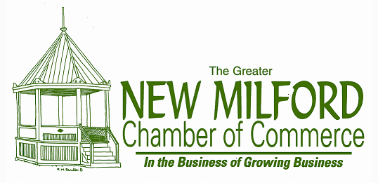

Wednesday, April 29th

5:30 to 7:30 pm

The Railroad Station

11 Railroad Street, New Milford

**5:30 to 6 pm Meet & Greet Open Networking**

**6 pm Our Panel**

* *Tom Barkal –* President Info Plexus Inc. – a computer sales service and consulting firm with 25 years of industry experience. Tom will discuss computer security and data protection strategies for the modern workplace.
* *Richard Herrington –* President with Nicholas/Tobin & Associates – Insurance Advisor. Richard will explain cost effective strategies to protect your business through the means of insurance.
* *Matt Lukens –* Lukens Consulting *-* a former Sr. Business Analyst for Shopzilla and Product Development Director for Synapse Group with more than 15 years in the industry, Matt is a certified Google Adwords professional with experience across venture-backed, "new market" start-ups. His current focus is leveraging business analytics to acquire traffic from Paid Search, SEO, Social Media and Strategic partnerships for his clients. Matt will provide tips and insights into keeping your mobile devices secure.

**7 pm Questions & Answers** Do you have specific questions for the panel? Email them to nmcc@newmilford-chamber.com.  
**Open Networking**

Free Admission / Refreshments to be served / RSVP by April 27th.

Click [here](mailto:nmcc@newmilford-chamber.com?subject=Yes%20I%20Will%20Attend,%204-29-15) to register.